Guía de aprendizaje– Fase 2 - Diseño y Programación Orientada a Objetos

Autor

Tutor/a
Nombre del Tutor/a
Código: 213023

Universidad Nacional Abierta y A Distancia - UNAD
Escuela
Programa
Año

Introducción:
El presente trabajo tiene como objetivo aplicar los conceptos fundamentales del paradigma de programación orientado a objetos (Poo) mediante el desarrollo de una solución practica en Python. Se aborda la implementación de clases, el sus del constructor__ INIT__ la gestión de atributos privados para el encapsulamiento y la interacción entre objetos dentro de una interfaz grafica desarrollada con el brete Tkinder.
Asimismo, se incluyen un análisis reflexivo sobre el impacto de las tecnologías modernas, como el desarrollo de software y la inteligencia Artificial, en la competitividad de las organizaciones actuales, destacando como la automación y el análisis de datos transformación la toma de sesiones.

1)Redactar un ensayo en inglés de no más de cuatro páginas sobre la relevancia del desarrollo de software y la Inteligencia Artificial (IA) en la competitividad empresarial. El ensayo debe analizar cómo estas tecnologías mejoran la eficiencia, optimizan procesos y potencian la innovación dentro de las organizaciones, destacando su impacto en la competitividad y en la capacidad de adaptación al mercado actual.
The Digital Pulse: Why Software and AI are the New Bedrock of Corporate Survival
The adage "adapt or die" has never felt more applicable to the business world in the current global environment. The days of technology being merely a support division located in an office building's basement are long gone. Artificial intelligence (AI) and software development are now essential components of any business hoping to stay relevant. Beyond the rhetoric surrounding "digital transformation," however, there is a more profound truth: these tools are the main drivers of contemporary business competitiveness.
The End of Manual Inefficiency
If we look back a decade, many processes relied on human intuition or manual data entry—methods that are prone to fatigue and error. This was altered by the emergence of custom software development, which enabled businesses to create tools that were suited to their unique "pains." By creating its own software, a business is codifying its competitive advantage rather than merely purchasing a product.
But the incorporation of AI into this software has been the true "game changer." Efficiency now involves doing tasks more intelligently rather than merely more quickly. For example, AI in logistics does more than just track packages; it forecasts weather patterns, traffic patterns, and fuel consumption to optimize routes in real-time. Businesses using traditional methods are unable to compete on price or speed due to the significant reduction in operational costs brought about by this level of optimization.

Innovation as a Constant, Not an Event
The capacity for innovation is one of a successful company's most human characteristics. Innovation was once thought of as an occasional "eureka" moment. Innovation is now an ongoing process because of AI and agile software development.
"Predictive Analytics," made possible by AI, enables companies to know what their customers want before they even realize it. Consider how e-commerce behemoths or streaming services make product recommendations. That isn't magic; it’s software analyzing patterns at a scale no human brain could match. By offloading the "heavy lifting" of data analysis to AI, human talent is freed to focus on creative strategy and high-level problem solving.
. This shift doesn’t just improve the product; it transforms the entire organizational culture into one that is proactive rather than reactive.
Adaptability: The Ultimate Competitive Edge
The modern market is notoriously volatile. We’ve seen how global events can shift consumer behavior overnight. In this context, software is the bridge to adaptability. A company with a robust digital infrastructure can pivot its business model—moving from physical sales to a fully automated digital storefront—in a fraction of the time it would take a traditional firm.
AI acts as a compass in this volatility. By processing market trends in real-time, it provides leaders with actionable insights, reducing the margin of error in critical decisions. Competitiveness today isn't just about who has the most capital, but about who has the best data and the most flexible software to act on it.
Conclusion
In conclusion, software development and AI are not just "trends" or "expensive add-ons." They are the fundamental pillars of 21st-century competitiveness. They enhance efficiency by eliminating the mundane, drive innovation by revealing hidden patterns, and ensure survival by providing the flexibility to adapt. For any business leader, the question is no longer whether to invest in these technologies, but how quickly they can integrate them into their core identity. In the race for the future, those powered by intelligent code are already miles ahead.

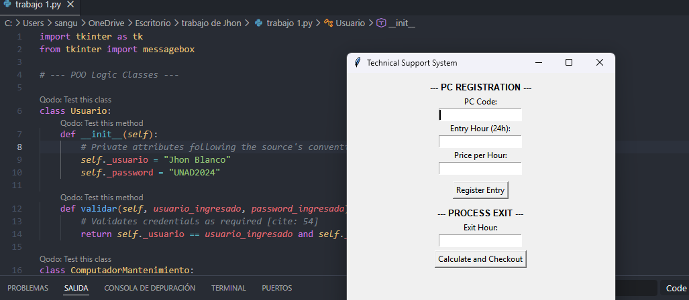
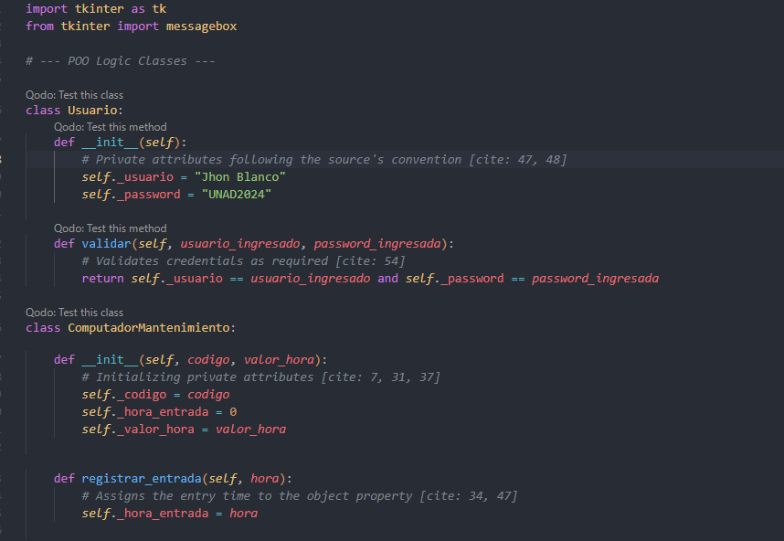
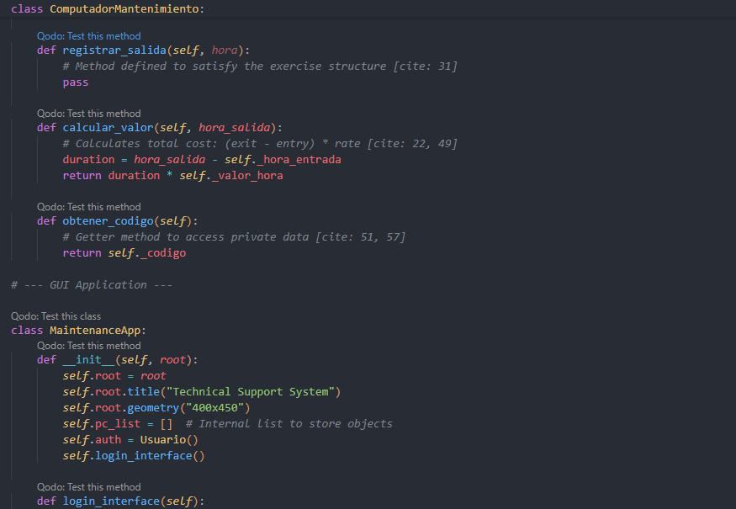
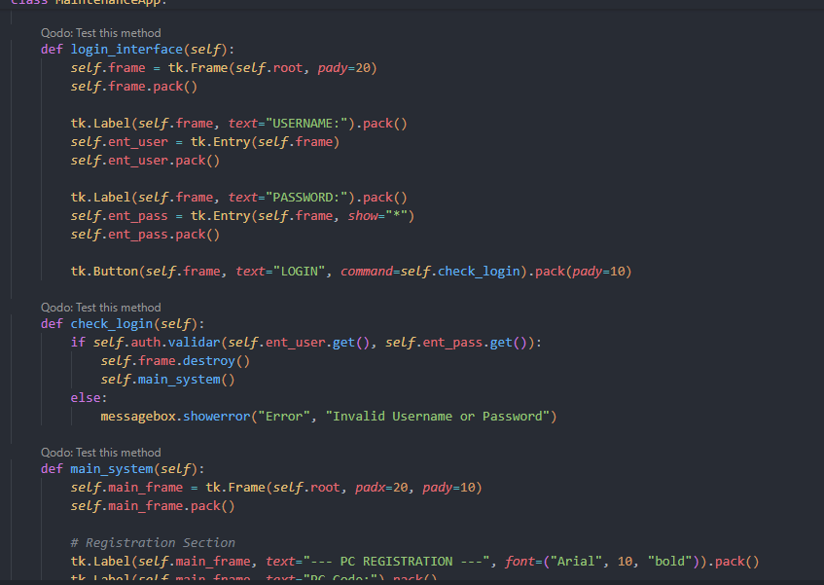
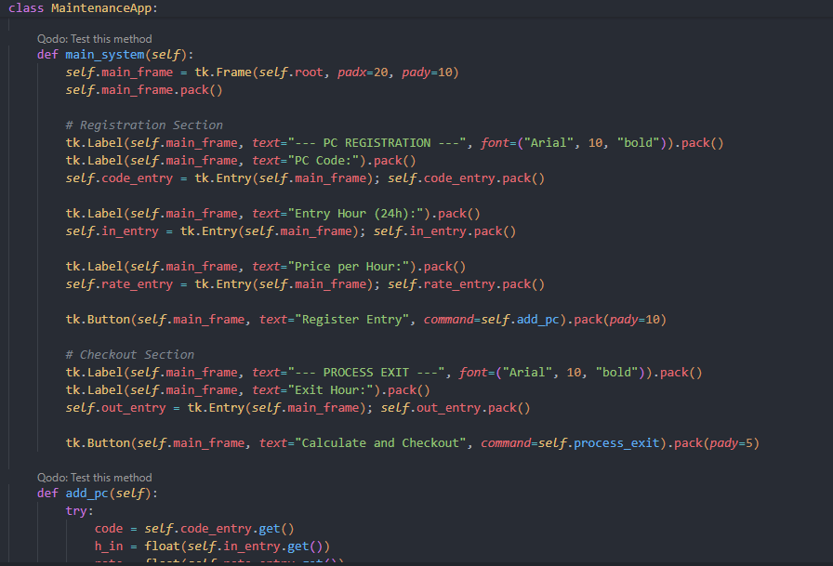
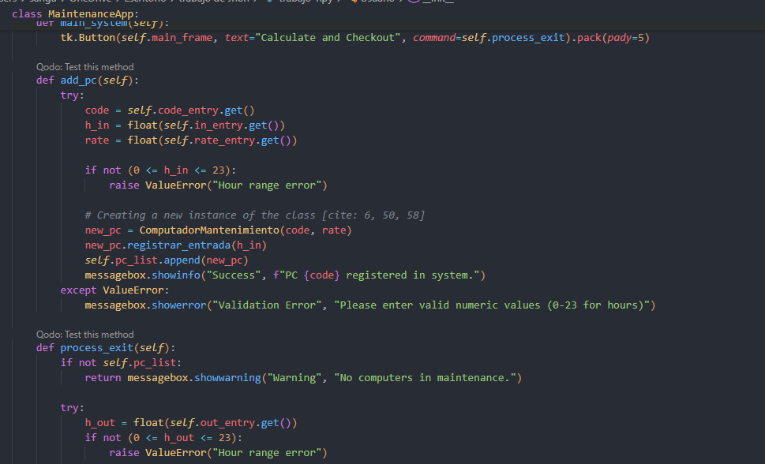
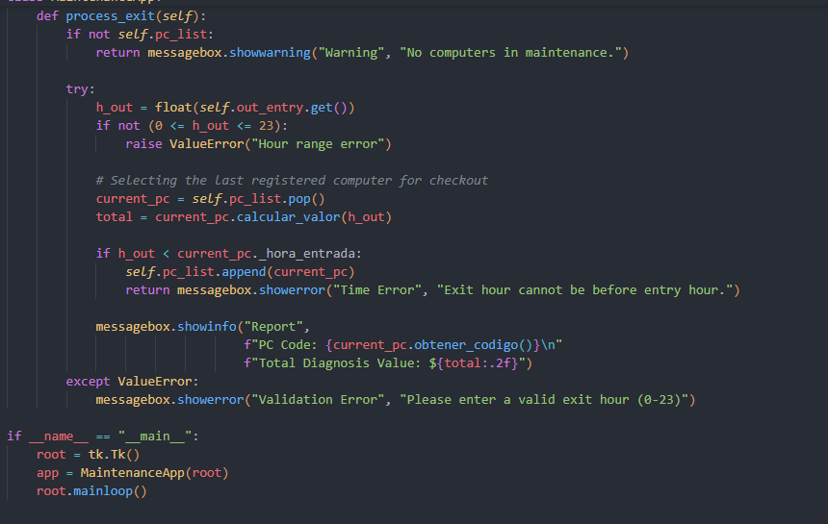



Conclusión:
El desarrollo de este ejerció permitió consolidar el uso de clases y objetivos como estructuras capaces de modelar problemas de la vida real. Se demostró que el encapsulamiento mediante atributos privados es vital para proteger la lógica interna del sistema, mientras que el uso de lista permite gestionar múltiples registros de manera dinámica. Finalmente se concluye que la integración de interfaz gráficas y la automatización mediante software no son solo ejercicios académicos, sino herramientas esenciales que define la eficiencia y competitividad de cualquier soporte técnico o empresa moderna.

Referencia Biográficas:
Aldana, J. M. (2024). Programación orientada a objetos. [Objeto Virtual de Información OVI]. Repositorio Institucional UNAD. https://repository.unad.edu.co/handle/10596/64491

Gutierrez, Y. Y. (2025). Clases abstractas. [Objeto Virtual de Información OVI]. Repositorio Institucional UNAD. https://repository.unad.edu.co/handle/10596/75904

Hinojosa Gutiérrez, Á. (2015). Python paso a paso. RA-MA Editorial. https://elibro-net.bibliotecavirtual.unad.edu.co/es/ereader/unad/107213?page=123

Parra, Y. Z. (2025). Introducción al uso de Tkinter. [Objeto Virtual de Información OVI]. Repositorio Institucional UNAD. https://repository.unad.edu.co/handle/10596/75884

Rodríguez Guerrero, R., Vanegas, C. A., & Castang Montiel, G. (2020). Python a su alcance. Editorial Universidad Distrital Francisco José de Caldas. https://research-ebsco-com.bibliotecavirtual.unad.edu.co/linkprocessor/plink?id=a05b1e42-2140-30bc-8d6c-1c87fc1bd7ee

Santanilla, V. E. (2025). Abstracción en Python. [Objeto Virtual de Información OVI]. Repositorio Institucional UNAD. https://repository.unad.edu.co/handle/10596/75883

Van Rossum, G., & Drake Jr, F. L. (2024). El tutorial de Python. Python Software Foundation. https://docs.python.org/es/3.12/tutorial/classes.html

